Development of Meteorological Module of Telemac-2D with applications to the Storm Surge

Ehsan Sarhadi zadeh

AnteaGroup

February 2014

This instruction describes the development of the Wind and Atmospheric Pressure Module of Telemac-2D. These changes allow the users to take the wind and pressure into account, which vary not only in time but also in space.

Since wind plays an important role in the actual threat of surges in the coastal areas (although low pressure also contributes a much smaller amount), the importance of such development is vital.

To do this, it is necessary to activate the logical keyword *AIR PRESSURE* and *WIND* in the steering file, which calls the **METEO** subroutine in each time step.

The influence of the wind on the water surface should be then defined by adding a value for *COEFFICIENT OF WIND INFLUENCE* parameter, proposed by Institute of Oceanographic Sciences as follow:

$${a_{vent}{×ρ}_{air}}/{ρ_{water}}=3.178206×{10}^{-6}$$

In order to avoid the instability in tidal flats with wet and dry fronts, wind must be set to zero below a threshold value of depth through *THRESHOLD DEPTH FOR WIND* (0.2 m).

The sets of input wind and pressure field are addressed in file *FORMATTED DATA FILE 1* either as ASCII or BINARY (netCDF). See appendix 1 for a complete description on structure of ASCII format.

To better understand how the METEO subroutine performs and updates the required Wind and Pressure, let's first take a look at its schematic layout algorithm:

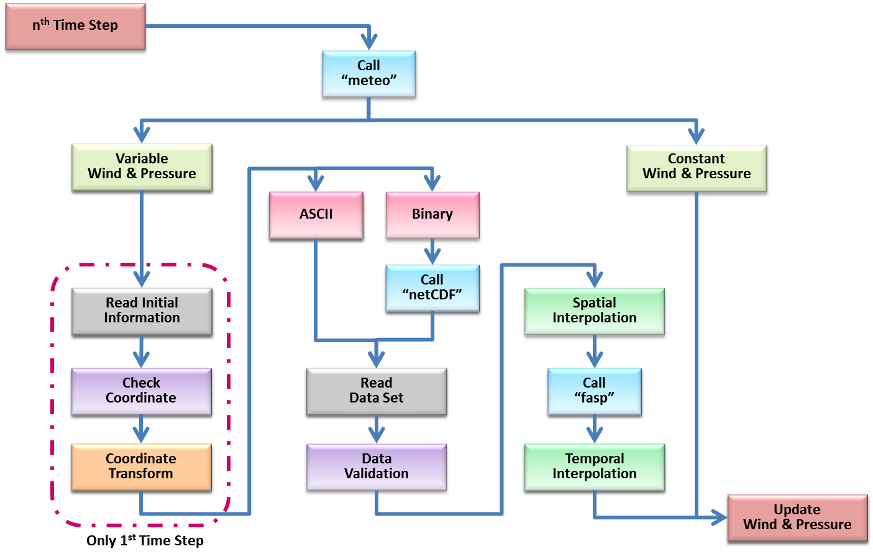

There is a keyword called *MY_OPTION* within the subroutine through which variable option is activated. The default value of that parameter is set to 2.

The format of input file may be selected by means of the keyword entitled *INPUT_FILE*, between ASCII and Binary. In the case of choosing Binary format, the netCDF library will be called up.

The METEO subroutine then reads the dimensions of the input file in order to allocate the appropriate size of the arrays e.g. the number of spatial and temporal intervals and the domain coordinates as well e.g. latitude, longitude and grid type.

In present version of Telemac only Mercator projection is implemented as a coordinate system which clipped between the φmax = ±85.05113° latitudes. The latitude values outside this range are ignored by METEO subroutine.

Since the most of the wind data have a regular grid type, a transformation from regular coordinate to Mercator projection is needed via the following equation:

$$\left\{\begin{aligned} x={Radius}_{Earth}×Longitude°×π/{180 } \\ y={Radius}_{Earth}×\ln{ \left(\tan{ \left({Latitude°}/{2×π/{180}}+π/4\right)}\right)}\end{aligned}\right.$$

Since the METEO subroutine is called up in each time step, the data that declare and read once, have to be kept for the next time step using *SAVE* command as long as a new set of data needs to be read from the input file with larger time step (3 or 6 hours). In the meanwhile, the data are updated by linear interpolation in time.

Once a new set of Wind and Pressure data are read, they are interpolated over the entire computational mesh. The interpolation is performed by means of **FASP** subroutine.

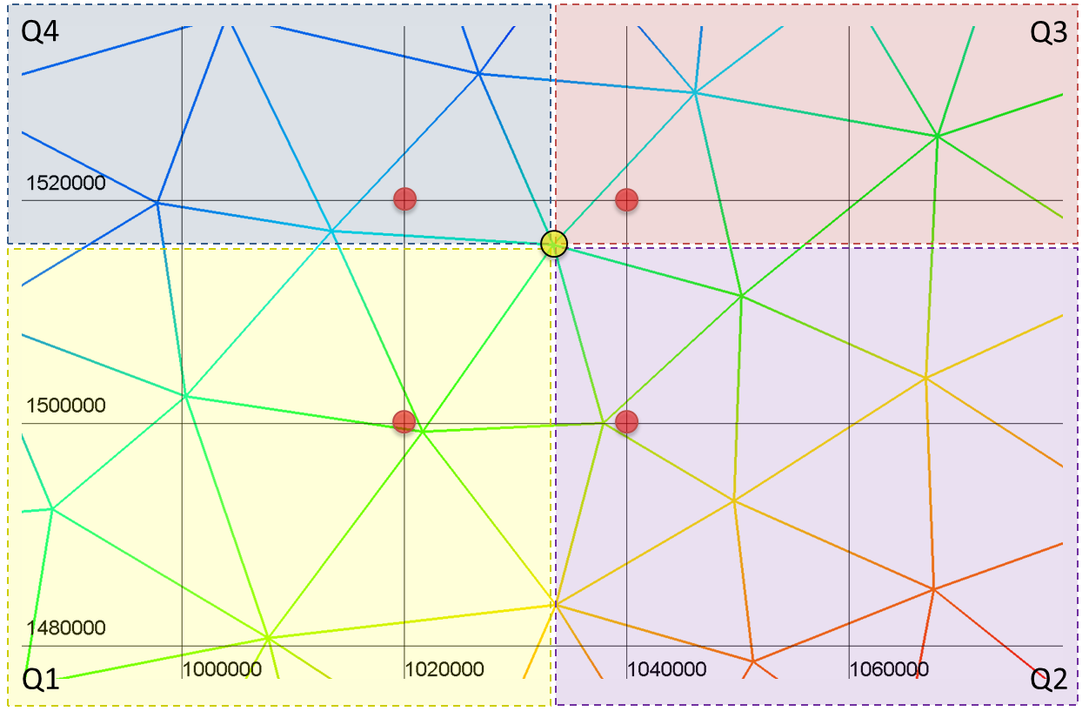

The FASP subroutine, which is actually designed for bottom topography interpolation, has been modified for this purpose. Calculation at each node (yellow dot) begins by dividing the computational domain to four quadrants. Then the closest data point (red dots) within the regular input grid is determined by iteration for each quadrant. Afterward, interpolation is done between these four neighbors.

As a final point, in order to evaluate the computation time in the case of Atmospheric Data, a case study for entire North Sea was run using Telemac-2D model in serial and parallel (16 cores) mode. The model contains a mesh with 58942 nodes and 110803 elements, 60 seconds of computational time step, and 3 hours of Wind and Pressure time step. Besides two different approaches for interpolation are implemented in this comparison, interpolation within the Telemac in each time step (Internal) and pre-interpolation outside the Telemac (External).





Since the spatial interpolation increase the computational costs, pre-interpolation is recommended in the case of the large and complex domains according to the above comparison.

**Appendix 1**

**Structure of ASCII format:**

TIMESTEP Xcells Ycells

“tn” “xn” “yn”

LONGITUDE °

“Long1” “Long2” “Long3" …

LATITUDE °

“Lat1” “Lat2” “Lat3” …

TIME s

FUAIR m/s

FVAIR m/s

ATMOS Pa (10E-5 atm)

“T1”

“U1” “U2” “U3” …

“V1” “V2” “V3” …

“P1” “P2” “P3” …

“T2”

“U1” “U2” “U3” …

“V1” “V2” “V3” …

“P1” “P2” “P3” …

“T3”

“U1” “U2” “U3” …

“V1” “V2” “V3” …

“P1” “P2” “P3” …

**Sample:**

TIMESTEP Xcells Ycells (281 × 201 × 173)

281 201 173

LONGITUDE ° (34773 points)

-12.0000000000000000 -11.8750000000000000 -11.7500000000000000 …

LATITUDE ° (34773 points)

48.0000000000000 48.0000000000000 48.0000000000000 …

TIME s

FUAIR m/s

FVAIR m/s

ATMOS Pa (10E-5 atm)

0

13.806104 13.481885 13.368604 …

-0.42619133 -0.38322258 -0.38712883 …

101149.125 101141.0 101133.5 …